Mayu Kunihisa
THE BUTTERFLY DREAM

June 18th (Sat) -July 27th (Wed)
Open：11:00 – 18:00（Tue - Thu） 11:00 – 19:00（Fri・Sat） Close：Sun・Mon

Sokyo Atsumi is pleased to announce a new exhibition by Mayu Kunihisa, titled "THE BUTTERFLY DREAM." This show is a continuation of works shown this spring at "THE BUTTERFLY EFFECT," Sokyo Annex in Kyoto. While focusing on the boundary between dreams and reality, we can get closer to the essence of her work.

Mayu Kunihisa was born in Osaka in 1983 and has exhibited primarily in the Kansai area. In 2019, she received a Special Prize at the 22nd Taro Okamoto Award. Her works were exhibited at Nishiwaki Okanoyama Museum of Art in Hyogo and in Seoul, Korea this year.

The exhibition title "THE BUTTERFLY DREAM" is taken from the famous fairy tale "The Butterfly Dream" by Zhuang Zi, a philosopher from the Warring States period in China.

"In my dreams, I became a butterfly and fluttered in the air, but when I woke up I returned to myself. Was I dreaming I was a butterfly? or am I now really a butterfly dreaming that I am a human…?”

This narrative is said to compare boundaries between dreams and reality, and how things change. Kunihisa states, "People tend to think of reality and dreams separately, but is that really the case? Ponding this question, I chose the title.”

In this show, Kunihisa will exhibit from her WIT-WIT series which she has been working on since 2014. The artist draws a series of arcs using her whole body as the axis letting centrifugal force propel the strokes of her arms. Inspiration for the name comes from the “Vitruvian Man,” a drawing made by Leonardo da Vinci around 1485, which itself was based on a description in De Architectura by the ancient Roman architect Vitruvius. The balanced proportions of the central human figure are shown through interlocking circles. Kunihisa’s main works are over three meters. On such large canvases as she paints a half circle at the full extension of her body, empty spaces are created in the center beyond her reach. These works have never been shown inside because of their size, and so we are pleased to show them at Sokyo Atsumi for the first time. In addition, Kunihisa will also show small pieces which were cut from the three meters canvas.

Kunihisa depicts light in the overlapping of half circles. The arcs painted freehand on the flat surface are visible but the artist adds that she is also depicting the straight lines from her body as she paints each point. The colors and flow of paint chosen according to her emotions, the seasons, the environment and temperature, all are making visible the invisible straight lines from her body. The white space created in the act of painting emphasizes the connection between paint and supports the illusions of the border between paint and space, reminds us of the butterfly dream and asks what is the relation between paint/ be painted.

Mayu Kunihisa
Born 1983 in Osaka, Japan, graduated from Foundation Diploma in Art and Design, Central Saint Martins, University of the Arts London in 2003 and from Graduate School of Art and Design, Kobe Design University in 2012.

Main solo exhibitions
2012 1day cafe presentation by kunihisamayu, Kobe Tenshodo, Hyogo, Japan
2018 wit-wit smile selection collection spring 2018, KOBE STUDIO Y3 ♯405, Hyogo, Japan IF ANYWHERE, Sojiro, Hyogo, Japan
2022 THE BUTTERFLY EFFECT, Sokyo Annex, Kyoto, Japan

Group Exhibitions include
2019 The 22nd Taro Okamoto Award for Contemporary Art Exhibition, Taro Okamoto
Museum of Art, Kawasaki, Kanagawa, Japan
2019 AQUA, pavart rome, Rome, Italy
2019 Rokko Meets Art 2019, Rokkosan Mountain, Hyogo, Japan
2020 +FUSION, Hyogo Prefectural Museum of Art Oji Branch Haradanomori Gallery, Hyogo, Japan

Major awards
2007 Grand Prize, Kobe Design University Serendip Competition
2017 Jury Prize of Ryoichi Matsuo, Reviewer Prizes of Mugi Nakajima and Yasuhito Mimura, UNKNOWN ASIA
2018 Special Prize, The 22nd Taro Okamoto Award for Contemporary Art
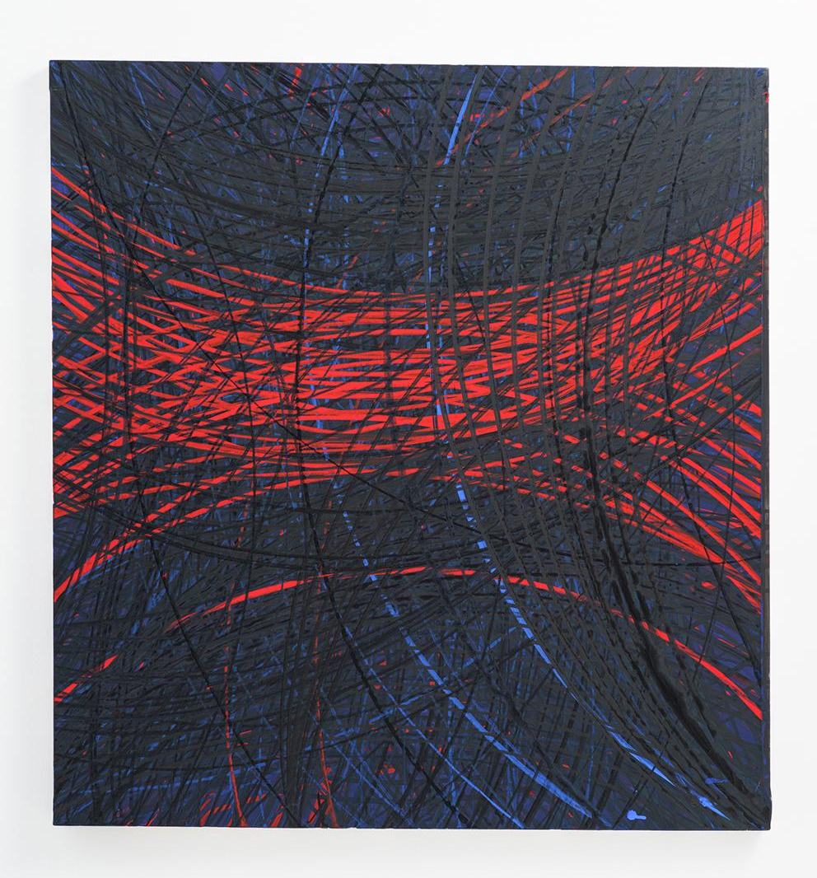

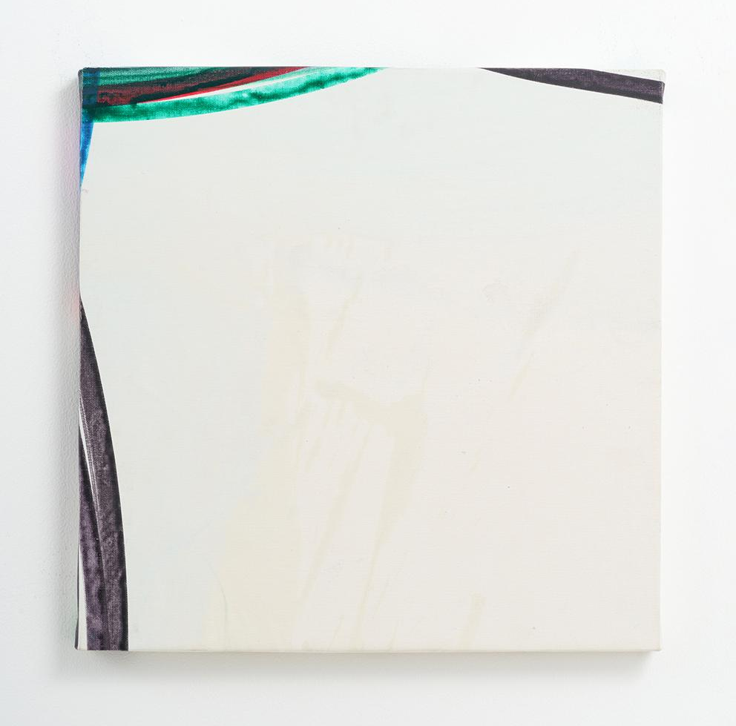

《STAR BRB》 2018 《AUTOLYSIS 15-36》 2021
Acrylic paint on canvas Acrylic paint on canvas, wooden panel
H91.3×W86×D3cm H41×W41×D1.9cm

Mail: sokyoAtsumi@gallery-sokyo.jp Tel: 080-7591-5212

